**PROBLEM NO: 2**

**DATE:**

**AIM:**

To write a python program, to count the number x in a given list of numbers*.*

**PROGRAM:**

def count(lst, x):

count = 0

for ele in lst:

if ele == x :

count=count+1

print(count)

lst =[]

n = int(input())

for i in range (0,n):

ele = int(input())

lst.append (ele)

x = int(input ())

count(lst, x)

**LINK:**

<http://103.53.53.18/mod/vpl/forms/edit.php?id=230&userid=1730#vpl_file0>

**OUTPUT:**

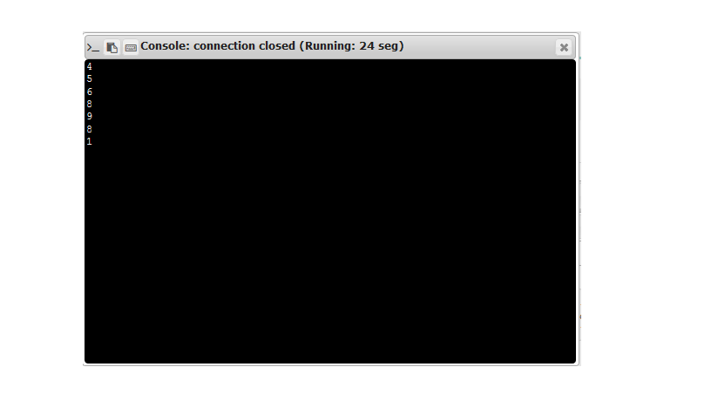

**RESULT:**

Counting the number x in a given list of numbers is done.